Name: ________________________________ Date: ___________________________________

Class: _________________________________ Teacher: ___________________________________

# Math Mini Quiz 6

This Mini Quiz, we’re going to explore the math concepts that you’ve learned so far in this unit. This assignment should take you about **20 minutes**.

1) Each of the equations is given in one of the forms that we talked about in class (standard, factored, vertex). For each one, ***label the form*** and ***write and label the other two remaining forms***

a) *y = 2(x - 5)(x + 1)*

b) *y = (x - 1)2 - 4*

c) *y = 2x2 + x - 1*

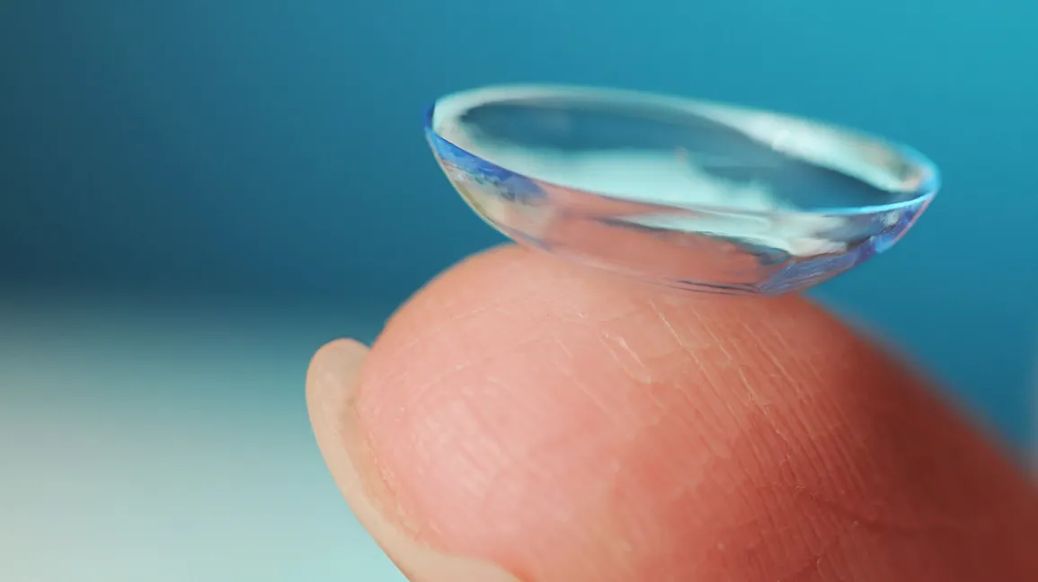2) Below you have the graph representing the shape of a contact lens[1], often considered a more convenient way of correcting vision than glasses. Its shape follows a quadratic equation (similar to the parabolic example we covered in class).

Write the function *y(x)* to express the shape of the contact lens. You may write it in any form that you would like. You may need to do some work, but not a lot of work to reach your answer.

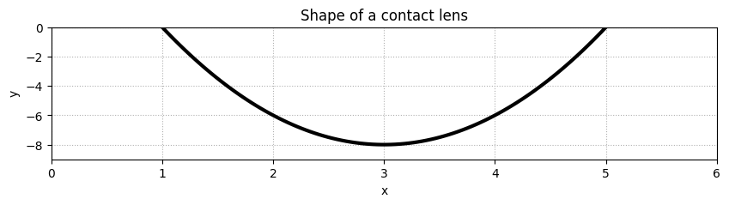

1. Contact lens image from https://www.healthline.com/health/eye-health/how-to-put-in-contact-lenses